Lab 5

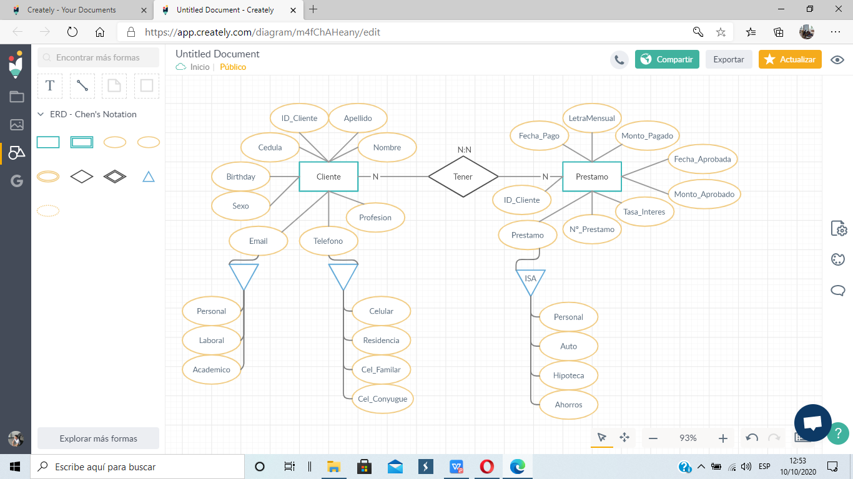

Modelo Lógico Normalizado

|  |  |  |
| --- | --- | --- |
| **Clientes** | | |
| Pk | ID_Cliente | N |
|  | Cédula | N |
|  | Nombre | N |
|  | Apellido | N |
|  | Sexo | N |
| FK | Cod_Profesión | N |

|  |  |  |
| --- | --- | --- |
| **Email** | | |
| PK | Cod_Tipo | N |
|  | Descripción | N |

|  |  |  |
| --- | --- | --- |
| **Profesión** | | |
| PK | Cod_Profesión | N |
|  | Descripción | N |

|  |  |  |
| --- | --- | --- |
| **Teléfono** | | |
| PK | Cod_Teléfono | N |
|  | Descripción | N |

|  |  |  |
| --- | --- | --- |
| **Cliente_Telefono** | | |
| PK, FK | ID_Cliente | N |
| PK, FK | Cod_Telefono | N |
|  | Telefono | N |

|  |  |  |
| --- | --- | --- |
| **Cliente_Email** | | |
| PK, FK | ID_Cliente | N |
| PK, FK | Cod_Tipo | N |
|  | Email | N |

|  |  |  |
| --- | --- | --- |
| **Tipo_Prestamo** | | |
| PK | Cod_Prestamo | N |
|  | Descripción | N |
|  | Tasa _Interes | N |

|  |  |  |
| --- | --- | --- |
| **Prestamo** | | |
| A | Nº_Prestamo | N |
| PK, FK | ID_Cliente | N |
| PK, FK | Cod_Prestamo | N |
|  | Fecha_Aprobada | N |
|  | Monto_Aprobado | N |
|  | Tasa_Interes | N |
|  | Letra_Mensual | N |
|  | Monto_Pagado | N |
|  | Fecha_Pagado | N |

Modelo Físico (DDL) Data Definition Language

